|  |  |  |  |  |  |  |  |  |  |  |  |  |  |  |  |  |  |  |  |  |  |
| --- | --- | --- | --- | --- | --- | --- | --- | --- | --- | --- | --- | --- | --- | --- | --- | --- | --- | --- | --- | --- | --- |
| *E-Book Management System*        **PROJECT PLAN**  **for**  **E-Book Management System**  **By:**  **Project ID:**  **R. Darsini (PES2201800107) – 1,2,3,5**  **Nitish S (PES2201800368) – 2,4,5,6**  **Nikita Ganvkar (PES2201800505) – 2,3,4,5**    **PES University, EC Campus**  **12-02-2021**   |  |  |  | | --- | --- | --- | | **Sl.No** | **CONTENT** | **PAGE NO** | | 1 | LIFECYCLE IDENTIFICATION | 2 | | 2 | IDENTIFICATION OF TOOLS TO BE USED | 3 | | 3 | DETERMINING AND CLASSIFYING THE DELIVERABLES | 3-5 | | 4 | WORK-BREAKDOWN STRUCTURE | 5-6 | | 5 | ESTIMATION OF EFFORT | 7 | | 6 | GANTT CHART | 8 |   1 |

**1: Identify the lifecycle to be followed for the execution of your project and justify why u have chosen the model.**

The lifecycle selected is an***Iterative*** approach.

An Iterative approach has been selected as it is most fitting for our project requirements and objectives. Some of the factors involved in deciding the Lifecycle approach has been listed in the table below along with how well each of the approach fares pertaining to a specific factor.

|  |  |  |  |  |  |  |
| --- | --- | --- | --- | --- | --- | --- |
| **FACTORS** | **Waterfall** | **V-**  **Shaped** | **Prototyping** | **Iterative** | **Incremental** | **Agile** |
| **Unclear User Requirement** | Poor | Poor | Good | Good | Poor | Excellent |
| **Reliable System** | Good | Good | Poor | Good | Good | Good |
| **Short Time Schedule** | Poor | Poor | Good | Excellent | Excellent | Poor |
| **Cost Limitations** | Poor | Poor | Poor | Excellent | Good | Excellent |
| **Visibility of**  **Stakeholders** | Good | Good | Excellent | Good | Excellent | Good |
| **Component**  **Reusability** | Good | Good | Poor | Excellent | Good | Poor |
| **Documentation** | Excellent | Excellent | Good | Excellent | Excellent | Poor |

Our project is a simple implementation of an online book management system with many reusable components, almost clear-cut user requirements and well-defined user-interface. These factors allow for the product to be built in multiple iterations wherein each iteration can incorporate the user’s feedback and requirements. This is a cost effective and easy method to test and debug in each of the smaller iterations.

After considering all of the above factors, an iterative approach seemed to be the best fit for our project implementation as this approach caters to all of the project needs.

**2: Identify the tools which u want to use it throughout the lifecycle like planning tool, design tool, version control, development tool, bug tracking, testing tool.**

The following tools are thought of to be used throughout the lifecycle:

1. **Planning Tools:**
2. **Design Tools:**
3. **Version Control Tools:**
4. **Development Tools:**
5. **Bug Tracking Tools:**
6. **Testing Tools:**

**3: Determine all the deliverables and categorize them as reuse/build components and justify the same.**

CBSE processes are software processes that support component-based software engineering. They take into account the possibilities of reuse and the different process activities involved in developing and using reusable components. There are two types of CBSE processes:

* + **CBSE for reuse** is concerned with developing components or services that will be reused in other applications. It usually involves generalizing existing components.
  + **CBSE with reuse** is the process of developing new applications using existing components and services.

For this project, we have focused on **CBSE with reuse** wherein widely available and popularly used components are ‘reused’ as per project requirements.

The following are the deliverables for this project in terms of components:

**USER AUTHENTICATION:**

|  |  |  |
| --- | --- | --- |
| **TASK** | **CATEGORY** | **JUSTIFICATION** |
| Sign Up Form | Reuse | Generic components like textboxes, dropdown lists and checkboxes needed for a sign-up form are widely used and easily available. |
| Login Page | Reuse | Generic components like textboxes, dropdown lists and checkboxes needed for a login page are widely used and easily available. |

**READING THE BOOK:**

|  |  |  |
| --- | --- | --- |
| **TASK** | **CATEGORY** | **JUSTIFICATION** |
| Navigating through book | Build | Switching to a specific page as well as page-to-page navigation requires components like pagination, toggle switch, breadcrumb, etc which have to be built as per project requirements. |
| Customization | Build | Changing font size and toggling between dark/light reading modes require components like toggle switch, font size slider, etc which have to be built as per project requirements. |

**BOOK DETAILS:**

|  |  |  |
| --- | --- | --- |
| **TASK** | **CATEGORY** | **JUSTIFICATION** |
| Display | Reuse | Displaying of basic information about the book including description, reviews, ratings need generic reusable components like textboxes, rating icons, etc. |
| User Interaction | Build | Submitting a rating/review requires customized components to promote better user interface. |

**BORROW BOOK:**

|  |  |  |
| --- | --- | --- |
| **TASK** | **CATEGORY** | **JUSTIFICATION** |
| Billing | Reuse | Billing requires user credentials, payment method details, secure gateway etc. which are features used in most online ventures and hence easily available to reuse. |
| Adding  Book to List | Build | Adding user-interested books to cart would require components like cart icon, books list table, etc which have to be built to incorporate better UI. |

**SEARCH BOOK:**

|  |  |  |
| --- | --- | --- |
| **TASK** | **CATEGORY** | **JUSTIFICATION** |
| Matching & Displaying Queries | Reuse | Searchboxes, query retrieval code, etc are widely used and easily available components |
| Filtering | Build | Filtering according to user interests would require customization of components. |
| Curating List | Build | A list of curated books aligning with users’ preference require customized components. |

**BOOKSHELF:**

|  |  |  |
| --- | --- | --- |
| **TASK** | **CATEGORY** | **JUSTIFICATION** |
| Display | Reuse | Displaying details about borrowed books need generic components like textboxes, etc. |
| Interaction | Build | Reading and eventually returning the books need special components to track date, time, etc and hence need to be built. |

**4: Create a WBS for the entire functionalities in detail.**

**WBS – Work Breakdown Structure**

A work-breakdown structure in project management and systems engineering, is a deliverableoriented breakdown of a project into smaller components. A work breakdown structure is a key project deliverable that organizes the team's work into manageable sections.

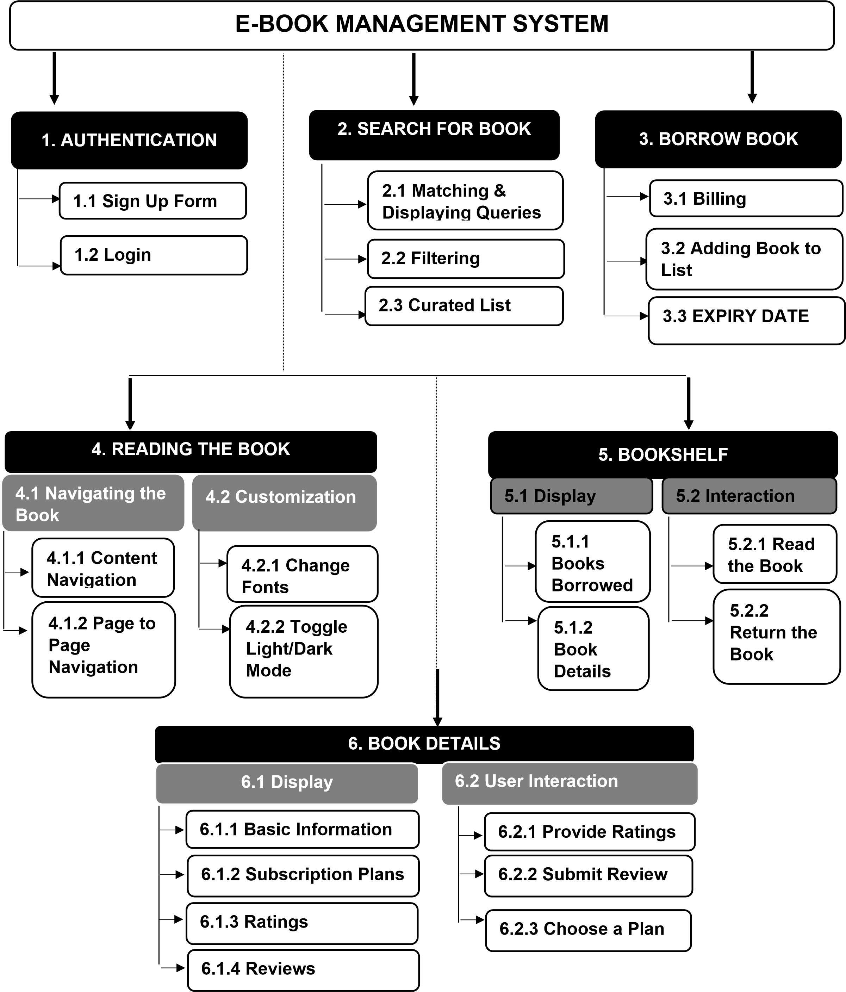

**5: Do a rough estimate of effort required to accomplish each task in terms of person months.**

Based on the above WBS, we calculate the effort required to accomplish each task in terms of person months. The procedure we have used is as follows:

1. Each task is divided into subtasks.
2. Each task including its subtasks is expected to have **900 lines of code** i.e. **0.9KLOC** (Kilo Lines of Code) on an average.
3. Also, assuming the project to be of **Organic type** due to small team size and well understood problem, the value of constants is **ab=2.4 and bb=1.05.**
4. The formula to calculate the **Effort in Person Months** for an Organic Project is given by:

**Effort E = ab * (KLOC)bb**

**Effort E = 2.4 * (KLOC)1.05**

|  |  |  |
| --- | --- | --- |
| **TASKS** | **KILO LINES OF CODE** | **EFFORT E in PERSON MONTHS** |
| **1. Authentication** | **0.9** | **2.2** |
| **2. Search for Book** | **0.9** | **2.2** |
| **3. Borrow Book** | **0.9** | **2.2** |
| **4. Reading the Book** | **0.9** | **2.2** |
| **5. Bookshelf** | **0.9** | **2.2** |
| **6. Book Details** | **0.9** | **2.2** |
|  |  | **13.2 ~ 13** |

The sum of the calculation of Effort for all the individual tasks add up to **13.2 Person Months ~ 13 Person Months.**

**6: Create the Gantt Chart for scheduling.**

**TENTATIVE TIMELINE FOR THE PROJECT: E-BOOK MANAGEMENT SYSTEM**

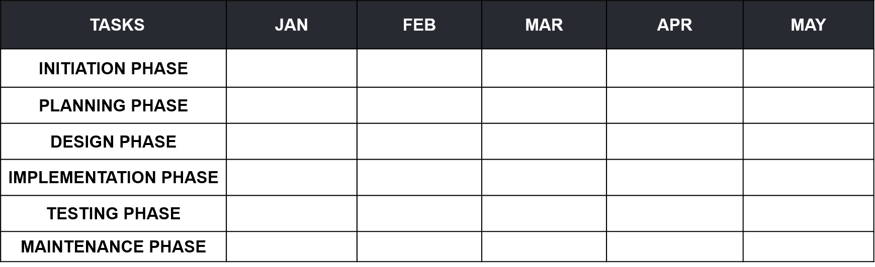

**INITIATION PHASE**

•

Finalization of Title

**PLANNING PHASE**

•

Requirements Documentation

•

Use Case Models

•

Choosing the Right SDLC

&

Tools

•

Determining the Deliverables

•

Designing the WORK BREAKDOWN STRUCTURE

•

Detailed Estimation of Efforts

**IMPLEMENTATION PHASE**

•

Project Implementation

Using OO Languages

**MAINTENANCE PHASE**

•

User Feedbacks

•

Software Refinements

**DESIGN PHASE**

•

Activity Diagram, Sequence Diagram, System

Architecture

•

State Diagram, Class Diagram, Component

Diagram

**TESTING PHASE**

•

Validating with the

Designed Test Cases

•

Evaluation and Final

Documentation